**PRIME DE FETE DU TRAVAIL 2023**

|  |  |  |  |
| --- | --- | --- | --- |
| **NOM** | **PRENOM** | **MONTANT** | **SIGNATURE** |
| AHONON | TANOH HYACINTHE | 5 000 |  |
| ATCHUI | MOCKE JUDICAEL | 5 000 |  |
| AKA | MOH N’DA MARIE LAURE | 5 000 |  |
| SENOU BI | TOH SEVERIN | 5 000 |  |
| BAMBA | JILUS SOULEYMANE | 5 000 |  |
| AHOULE | JEAN DANIEL | 5 000 |  |
| AKA | MARCELLE | 5 000 |  |
| GUE | DROH GERMAIN | 5 000 |  |
| AGBE | BOLIGA | 5 000 |  |
| BENTHO | PADRET LEO | 5 000 |  |
| AMOAKON | RENE | 5 000 |  |
| ASSI | CESAR | 5 000 |  |
| TOTAL | | 60 000 |  |

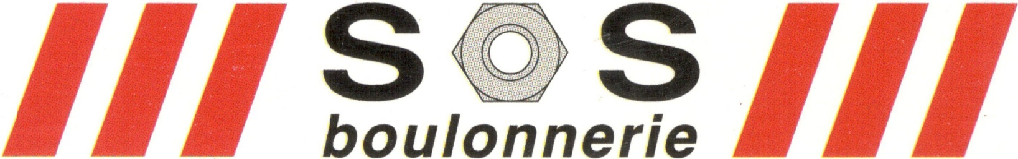

**LA DIRECTION**